Health ANSWERS Multidisciplinary Roundtable for Older Persons’ Health 2026

Invitation to Help Shape Consumer-Researcher Panel

Health ANSWERS needs your help to shape a conversation about health research collaborations between consumers and researchers. We invite you to help shape the Consumer-Researcher Panel at the Multidisciplinary Roundtable for Older Persons' Health 2026.

What we are planning
We are bringing together 5 consumers and carers alongside 5 researchers for a 60-minute conversation about what good partnership between researchers and consumers looks like. Inspired by the ABC's "You Can't Ask That", the panel creates space for honest questions in both directions. The aim is not to put anyone on the spot. It is about clearing up misconceptions and building genuine understanding.

What we are looking for
Do you have a burning question you have always wanted to ask researchers about consumers and health researchers working together, but never had the courage or opportunity to ask it? We are looking for you. No question is too silly, awkward, embarrassing, naive or funny. We want genuine curiosity – the questions you have always wanted to ask but have not had the chance.

Who can submit questions
If you are a consumer who has worked with researcher or policy makers or wants to engage with researchers, you can submit a question. All questions get reviewed, and we will select a mix for the panel discussion at the Roundtable. All submissions will help shape the conversation, even if your question is not selected for the panel.

How to submit a question
Submit your questions via the link or scanning QR code below before Friday, 2 October 2026. You can submit multiple questions

Link: MDT Roundtable You Can't Ask That Consumer questions – Fill in form

QR code:
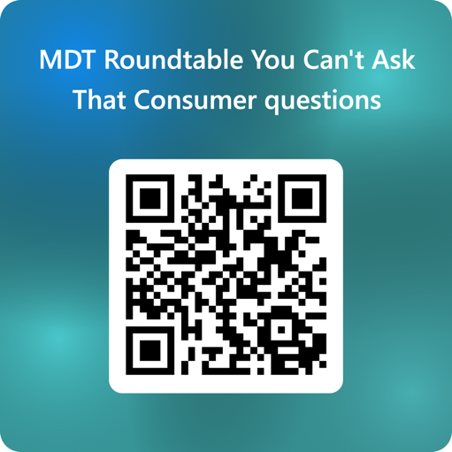

What happens after the event
When you submit a question, you can choose whether you would like to provide your email address to receive a link to the event recording once it is complete. We will not contact you for any other reason. Your question will be reviewed and selected anonymously, and your contact details will not be shared with anyone outside the Health ANSWERS team.

About the event
- Date: 15 October 2026
- Time: 1:00pm and 4:30pm (panel discussion is 60 minutes)
- Location: Amberfield by LDK, 240 Cotter Rd, Weston ACT 2611, Australia
- Event: this session is part of the Health ANSWERS Multidisciplinary Roundtable for Older Persons' Health 2026

About Health ANSWERS
Health ANSWERS is a Research Translation partnership working on bringing together clinicians, researchers, consumers, and health services across ACT and South-Eastern NSW to turn evidence into real-world health improvements. Consumer partnership sits at the heart of everything we do because research done with communities, not on them, leads to better outcomes.

About the Multidisciplinary Roundtable for Older Persons' Health
The Roundtable is a day where clinicians, researchers, consumers, and service providers from across ACT and South-Eastern NSW come together to share new programs and interventions improving health of older people, talk about what is working and what is not in aged care research and practice, and strengthen collaboration across the region.

